**DAILY ONLINE ACTIVITIES SUMMARY**

|  |  |  |  |  |  |  |  |  |
| --- | --- | --- | --- | --- | --- | --- | --- | --- |
| **Date:** | **14-7-2020** | | | | | **Name:** | **Poojashree T** | |
| **Sem & Sec** | **8th sem B sec** | | | | | **USN:** | **4al16cs064** | |
| **Online Test Summary** | | | | | | | | |
| **Subject** | | **No Test** | | | | | | |
| **Max. Marks** | |  | | **Score** | | |  | |
| **Certification Course Summary** | | | | | | | | |
| **Course** | **Machine Learning Foundation** | | | | | | | |
| **Certificate Provider** | | | **Great learning academy** | | **Duration** | | | **3.0hr** |
| **Coding Challenges** | | | | | | | | |
| **Problem Statement:** **1**. **to read the number and compute the series.**  **2. to count the number in th series.**  **3. to check whether number is palindrome or not.**  **4. to find the number between 0 and 50 which are not divisible by 2 and 3.**  **5.micro and array update**  Top of Form | | | | | | | | |
| **Status:completed** | | | | | | | | |
| **Uploaded the report in Github** | | | | | **yes** | | | |
| **If yes Repository name** | | | | | **Poojatgowda** | | | |
| **Uploaded the report in slack** | | | | | **yes** | | | |

**Online test**

No Test

**Certification course**

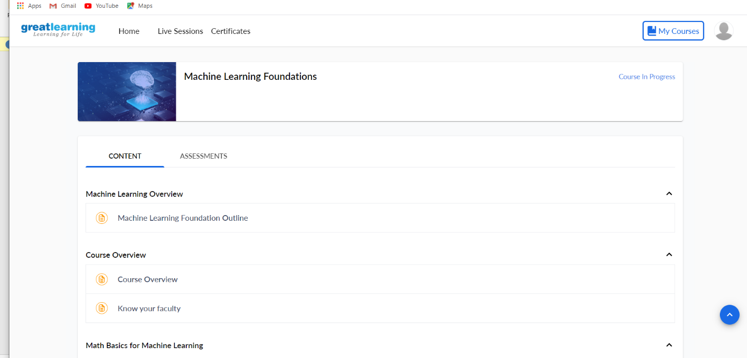

**C Program – Sorting of a Set of Strings in Ascending alphabetical order**

/* This program would sort the input strings in

* an ascending order and would display the same

*/

#include<stdio.h>

#include<string.h>

int main(){

int i,j,count;

char str[25][25],temp[25];

puts("How many strings u are going to enter?: ");

scanf("%d",&count);

puts("Enter Strings one by one: ");

for(i=0;i<=count;i++)

gets(str[i]);

for(i=0;i<=count;i++)

for(j=i+1;j<=count;j++){

if(strcmp(str[i],str[j])>0){

strcpy(temp,str[i]);

strcpy(str[i],str[j]);

strcpy(str[j],temp);

}

}

printf("Order of Sorted Strings:");

for(i=0;i<=count;i++)

puts(str[i]);

return 0;

}